Family : staphylococaceae
Genus : Staphylococcus
The most important pathogenic spp. are
- Staphylococcus aureus or pyogenes : Infected human & many animal spp.
- S. capitis , S. haemolyticus infected human
- S. intermedius infected dog & cat .
- S. hyicus infected pig
Non pathogenic spp. are :
- S. epidermidis 2. S. saprophytes 3. S. equorum 4. S. gallinarum
Morphology & Staining :
The staphylococci are Gram positive cocci that tend to be arranged in irregular cluster of grapes formation . Some time found in paris or single . In old culture tend to Gram negative stain .

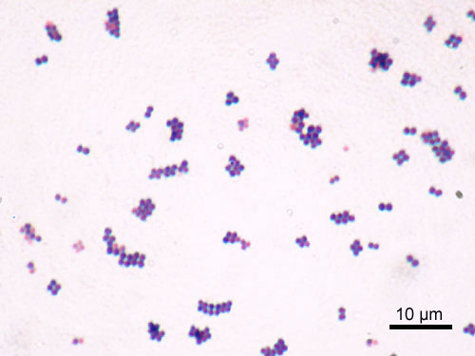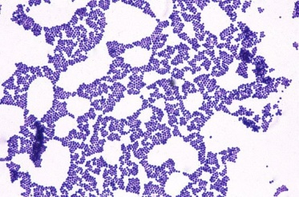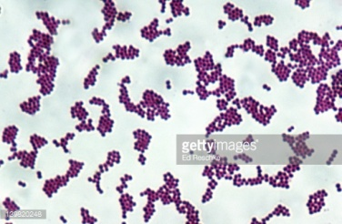

Distribution in nature :
These organisms occure commonly on the skin , anterior nares , saliva , intestine, faeces of human & animals as well as in water, soil & air . S. aureus most important human pathogen, although its frequently a part of the normal microflora its can cause diseases such as mastitis in cattle& ewe, tonsillitis in dogs, septicemia in poultry, wound infection , toxic shock syndrome, toxiemia & sudden death.
Cultural characterstic :
The staphylococci are aerobic & facultative an aerobes, catalase + for differentiate it from strept. Spp. , They don’t form spore or capsule ,non motile , its tipical mesophiles , grow at an optimum temperature of 37 ºc
Virulance factores of S. aureus :
- Capsular polysaccharides, peptidoglycan ,teichoic acids & protein A

1

- Coagulase enzymes . causing the coagulation of blood plasma (coagulase +) & other strains don’t produce this enzyme & are non pathogenic ( coagulase test _ ) . 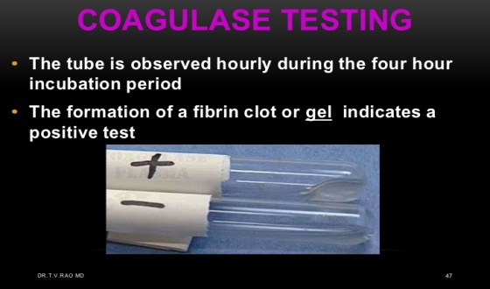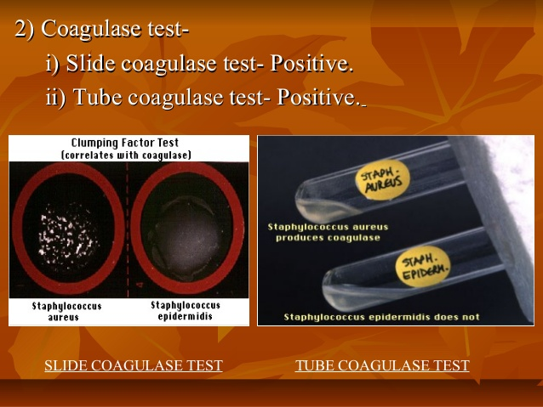
- Toxins which associated with abscess formation .
- Staphyloxanthin is a pigment responsible for S. aureus characteristic golden colour that acts as a virulence factor .
Staph Identification on agar media :
- Nutrient agar : growth is good & relatively large colonies . grow at 37ºc , they are circular, convex, glistening with an entire edge, The colour may vary from white to yellow
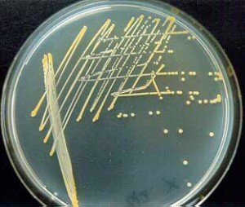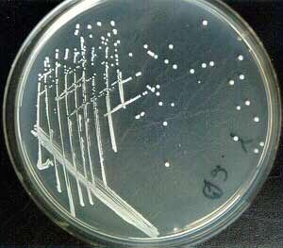
Staph. aureus staph. epidermides
- Blood agar : strains produce hemolysine are cause ( alpha, Beta, Gamma) hemolytic colonies. The strains are surrounded by zones of hemolysis, colonies are circular,smooth,opaque, yellow colony in color of S. aureus while S. epidermidis white in color.
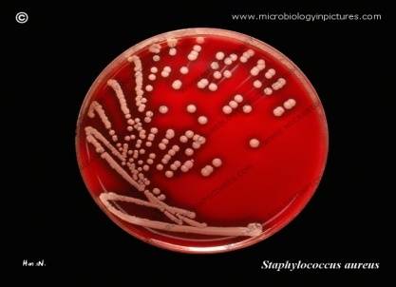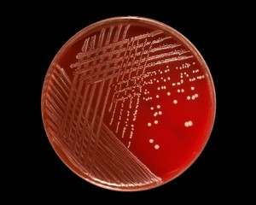

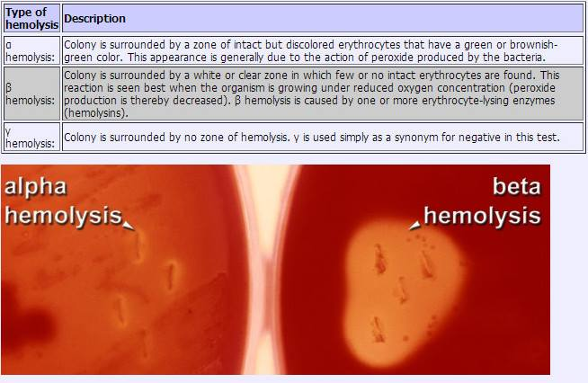

2

- Mannnitol salt agar : this media selective & differentials for selection of S. aureus & S. epidermides
S. aureus will ferment mannitol in presence of Nacl 7% , In this media phenol red is indicater . so it fermentation of mannitol will change the PH into acid & this will give a bright yellow color.
But S. epidermides didn’t ferment mannitol & use peptone in the medium which give (NH₃) ammonia & the PH will be alkaline the colony appear bright pink color .

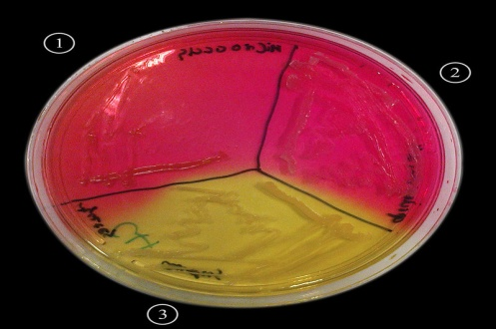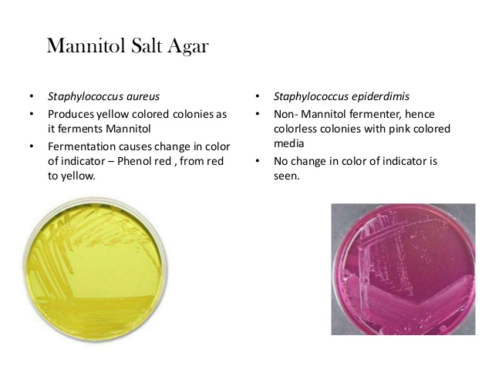

- Staph 110 media : Is a typical for isolation pathogen staph . which contain gelatin,mannitol,5-10% Nacl. This media is selective because they don’t have indicater so pigmented colonys which are highly selective for Nacl will liquefied gelatin & ferment mannitol & give orange colony .
Biochemical test : Good growth in nutrient broth & give turbidity . both catalase & urease are + , nitrates are reduced to nitrites + ,acid without gas is produced by most strains in glucose, lactose,maltose,sucrose & mannitol fermented, methyl red & gelatinase are + , voges- proskaur reaction are variable, Indol &oxidase _ & H2S are not produce.
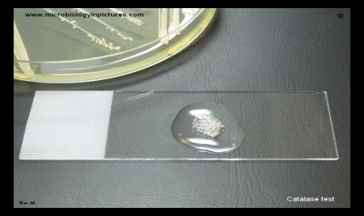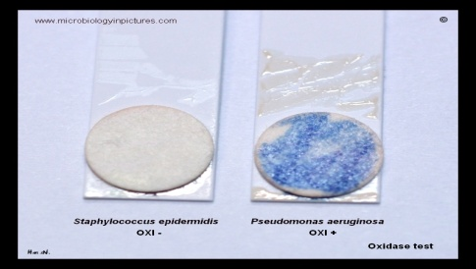
Haemolysis : the staphylococcal haemolysins (alpha,beta,gamma) can be produced singly or combination or nat at all. S. aureus & S. intermedius are haemolytic & produce both alpha & beta lysine & exhibit double haemolysis .
- Alpha lysine is responsible of narrow zone of partial haemolysis.
- Beta lysine is responsible of clear zone of complete haemolysis around the colony.
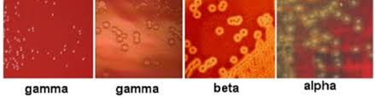
3

Biochemical Reaction :
Spp. | Coagulase test | Hemolysis | urease | Mannitol agar (fermented) | Maltose fermented
1.S. aureus | + | Alpha& beta | + | + | +
2.S.intermedius | + | Alpha& beta | + | + | + , -
3.S.epidermidis | - | - | + | - | +
4.S.saprophytes | - | - | + | + | +

Characterstic of S. aureus Characterstic of S.epidermidis
1.pathogenic | 1.saprophyte or non pathogen
2.golden-yellow colony on blood agar | 2.white colony
3.beta- haemolysis | 3.non haemolysis
4.mannitol ferment | 4.non ferment
5.coagulase + | 5. coagulase -
6.gelatinase + | 6.gelatinase -

Dr. Ban Sahib Abedul-Nabi
Zoonotic disease unit
post graduate lecture

4

